ASTA607_22424606

QUESTION 1
(a)
library(MASS)
data("crabs")

- The crabs dataset has 200 rows and 8 columns.
- It describes 5 morphological measurements of 50 crabs
- Each crab has 2 colour forms and of both sexes.

(b)
data("crabs")

'data.frame': 200 obs. of 8 variables:
$ sp : Factor w/ 2 levels "B","O": 1 1 1 1 1 1 1 1 1 1 ...
$ sex : Factor w/ 2 levels "F","M": 2 2 2 2 2 2 2 2 2 2 ...
$ index: int 1 2 3 4 5 6 7 8 9 10 ...
$ FL : num 8.1 8.8 9.2 9.6 9.8 10.8 11.1 11.6 11.8 11.8 ...
$ RW : num 6.7 7.7 7.8 7.9 8 9 9.9 9.1 9.6 10.5 ...
$ CL : num 16.1 18.1 19 20.1 20.3 23 23.8 24.5 24.2 25.2 ...
$ CW : num 19 20.8 22.4 23.1 23 26.5 27.1 28.4 27.8 29.3 ...
$ BD : num 7 7.4 7.7 8.2 8.2 9.8 9.8 10.4 9.7 10.3 ...

Two columns, ‘sp’ and ‘sex’ are factors, the ‘index’ column is an integer, and the rest of the columns(5 of them) are numerical.

(c)
table(crabs$sp)
table(crabs$sex)

OUTPUT:
B O
100 100

F M
100 100

(d)
par(mfrow=c(1,2))
barplot(sp_table, xlab = "Species", ylab = "Number of Crabs",
main = "Composition Across Species", col = c("blue", "orange"))
barplot(sex_table, xlab = "Sex", ylab = "Number of Crabs",
main = "Composition Across Sex", col = c("lightblue", "lightpink"))

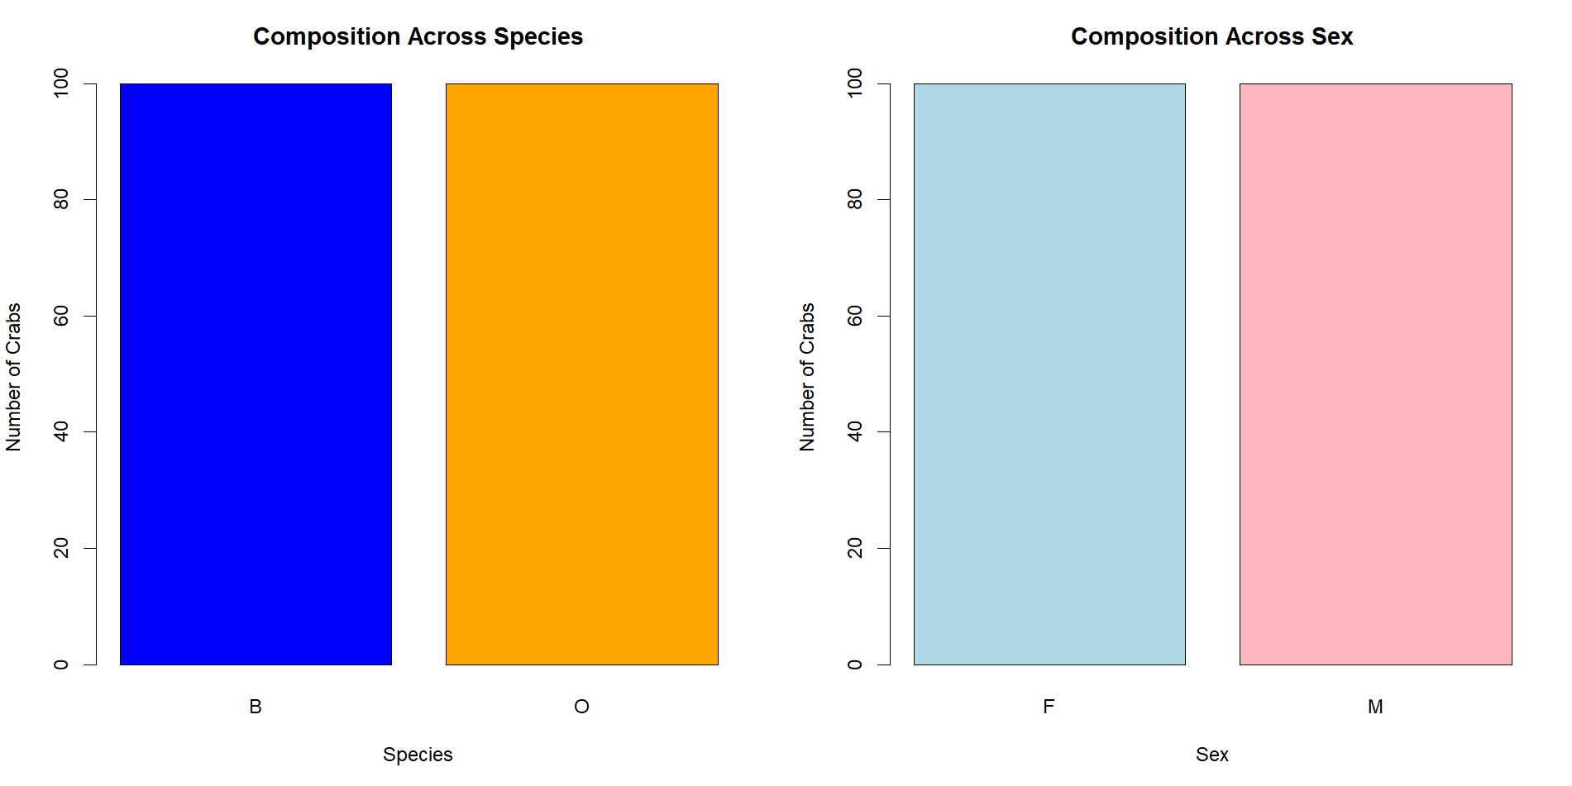
(e)The dataset is balanced across all four groups, as equal frequency (100) is observed across the groups. This gives the confidence that future variations that may be observed later is not due to unequal number of observations for the groups.

QUESTION 2
(a)
par(mfrow=c(1,2))
boxplot(BD~sp, crabs, col = c("blue", "orange"),
main= "Distribution of Body Depth Across Species", ylab="Body Depth")
boxplot(BD~sex, crabs, col = c("lightblue", "lightpink"),
main= "Distribution of Body Depth Across Sex", ylab="Body Depth")

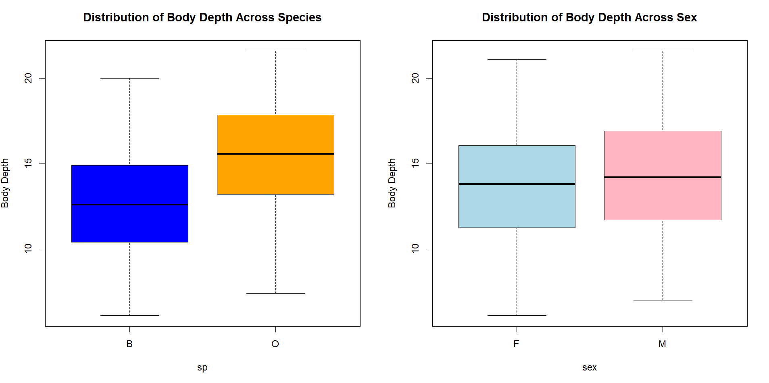
The distribution of body depth for orange species is slightly higher than that of the blue species. It is observed that it has a higher minimum value, median, and maximum value. This suggests that the orange species records higher values. Also, there is not much difference in variability across both species.
Within the sex groups, both male and female show very similar distribution of body depth values, with the minimum, median, and maximum body depth values of males just slightly higher. The boxes also show very similar variability.
Among the groups(species and sex), middle values fall within similar range and there is no significant visible difference in variation. Also, no outliers are observed in any of the groups.

QUESTION 4
par(mfrow=c(1,2))
hist(crabs$CL[crabs$sp=="B"], col = "blue", xlab = "CL for Blue Species ",
main = "Distribution of Carapace lengths Across Species(B)")
hist(crabs$CL[crabs$sp=="O"], col = "orange", xlab = "CL for orange Species ",
main = "Distribution of Carapace lengths Across Species(O)")

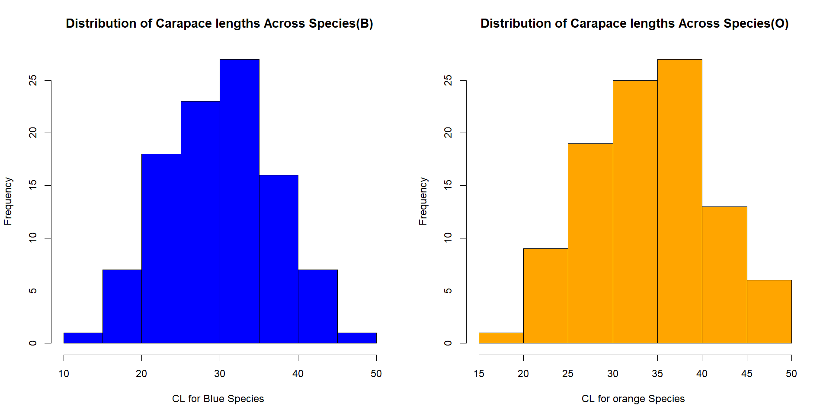
Comment on the distribution of carapace lengths across the blue species:
The carapace lengths for the blue species range from 10 to 50, with a peak at 30-35. The distribution is unimodal, and very slightly skewed to the left.
Comment on the distribution of carapace lengths across the orange species:
The distribution ranges from 15 to 50, with very small number of species in range 15-20. This suggests that the orange species has generally higher Cl values, as compared to the blue species. Also, the distribution is unimodal with observed peak at 35-40, and is slightly skewed to the left.

QUESTION 4
(a)
sp_means<-aggregate( . ~ sp, crabs[, c("sp", "FL", "RW", "CL", "CW", "BD")], FUN = mean)
sex_means<-aggregate( . ~ sex, crabs[, c("sex", "FL", "RW", "CL", "CW", "BD")], FUN = mean)

sp FL RW CL CW BD
1 B 14.056 11.928 30.058 34.717 12.583
2 O 17.110 13.549 34.153 38.112 15.478

sex FL RW CL CW BD
1 F 15.432 13.487 31.360 35.830 13.724
2 M 15.734 11.990 32.851 36.999 14.337

(b)
par(mfrow=c(1,2))
barplot(as.matrix(sp_means), col = c("blue","orange"),
main="Mean Distribution of Morphological Measurements Across Species")

barplot(as.matrix(sex_means), col = c("lightblue","pink"),
main="Mean Distribution of Morphological Measurements Across Sex")

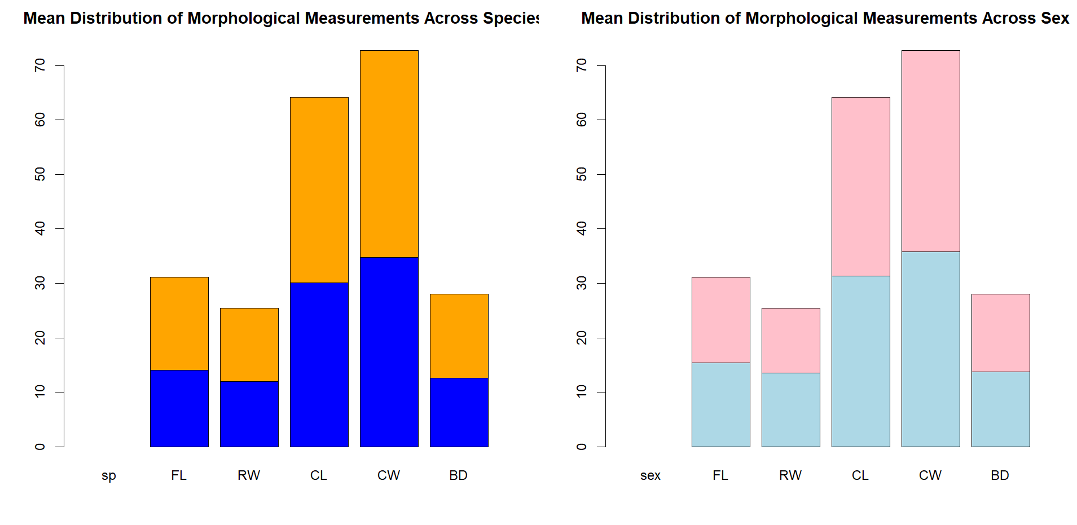
(c) Species and sex difference is very little for all measurements. However, the greatest species difference seems to be observed in the FL/CW measurements. And, the least sex variation is observed in the CW measurements.

QUESTION 5
(a)
pairs(crabs[, (4:8)])

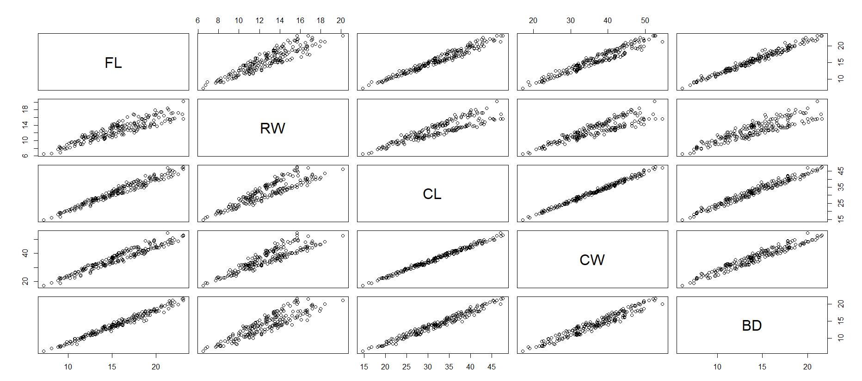

Generally, a strong positive linear correlation is observed among all variable pairs. The points are consistent, with no extreme values breaking the chain.

QUESTION 6
Statistical Report
The crabs dataset contains 200 observations of 50 crabs, evenly balanced across two species (blue and orange) and two sexes (male and female). Each crab is described by five morphological measurements: femur length (FL), rear width (RW), carapace length (CL), chest width (CW), and body depth (BD). The balance across species and sex groups implies that future variations cannot be attributed to unequal sample sizes across groups.
When the various morphological measurements are analyzed, it is observed that there are higher measurement differences across species, i.e. orange crabs have higher measurement values than blue crabs. Across sexes, difference in measurements are relatively small. This is evident from the distribution of averages across groups. The boxplots and histograms of two measurements (BD and CL) confirm that distributions are unimodal, mostly symmetric, and without extreme outliers, indicating stable and consistent measurements across groups. This generalization to the other measurements (FL, RW, and CW) is safe because pairwise plots reveal strong positive linear correlations among all morphological variables. The pairwise plots also suggest that crabs with larger values in one measurement tend to have larger values in others.
Overall, the dataset is stable, and observed differences are results of true biological variation rather than irregularities in the data.

